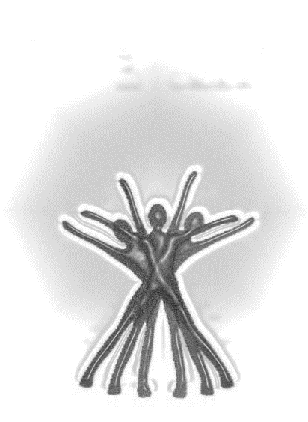

**INDIANA COUNTY RECOVERY CENTER (ICRC)**

**“Shining the Light and Life of Recovery on Individuals, Families, and Community****”**

**574 PHILADELPHIA STREET, 2nd Floor, INDIANA, PA 15701**

**A RECOVERY COMMUNITY CENTER (RCC)**

**A RECOVERY ORIENTED SANCTUARY ANCHORED IN THE HEART OF THE COMMUNITY.**

It exists to put a face on recovery, to build recovery capital, and to serve as a physical location where we can organize the local recovery community’s ability to care. An RCC is not a treatment agency, it is not a 12 Step club, it is not a drop-in center although aspects of all of these are apparent.

* An RCC will deliver peer-to-peer recovery support services using its volunteer force as the deliverers of these services.
* An RCC is not a place for people to simply hang out, watch TV, play cards, or pool, and attend a daily meeting. We are not seeking to duplicate existing resources.
* An RCC will host specific social events.
* An RCC is not a drop-in center whose primary purpose is to refer and help people get into treatment.

People in need of help will enter the RCC and with expectations that we will do everything in our power to assist them. RCC’s are places where the following recovery support services are offered:

* Certified Recovery Specialist (CRS) services offered by appointment
* Recovery Coaching
* Recovery Meetings including MARA (Medication Assisted Recovery Anonymous)
* Recovery Training Series with PCB Education Providers
* CCAR Recovery Coach Academy & Ethics for Peer Providers
* Family Support Groups
* Family Recovery Education
* Recovery Social Events
* Telephone Recovery Support
* Community Allies’ Presentations
* Services that the Recovery Community Voices deem necessary

**For more information, Email us:** [**recoverycenterindianacounty@gmail.com**](mailto:recoverycenterindianacounty@gmail.com) **or call: 724.717.6492**