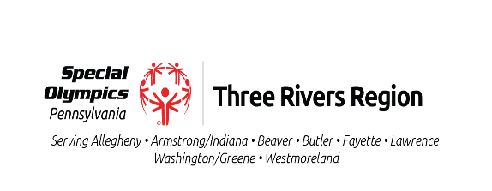Armstrong/Indiana Counties

Welcome New Athletes

Participation in Special Olympics training and competitive events is open to all individuals with intellectual/developmental disabilities, regardless of the degree of challenge they face.

Athletes aged 7 and above are eligible to train, while those aged 8 and older are eligible to train and compete. Participation, including uniforms, equipment, and competitions, is **free.**

To be eligible to participate, athletes must have an intellectual disability, cognitive delay, or developmental disability characterized by functional limitations in both general learning and adaptive skills.

Before an athlete can participate, the athlete or the athlete’s parent/guardian must complete the Athlete Portal intake*.* This will require the athlete to provide their personal information, including a valid **email address** and **phone number**.

Submit the application on the Special Olympics Pennsylvania website, [specialolympics.org](C:\\Users\\Anyone\\Downloads\\SOAI 2025\\2025 Athlete Welcome Letter.docx) . Once we receive your application, a coach will contact you to provide the sports schedule for the season, along with all necessary information.

Benefits of becoming an athlete include, but are not limited to:

Amazing friendships on and off the field, being part of one of the largest social networks, receiving free health screenings, becoming more physically active, and gaining self-confidence and self-esteem.

**SPORTS:** Our local program offers long-distance running/walking and bocce in the fall, snowshoeing and bowling in the winter, and athletics (track & field) in the spring. We are expanding to include clinics for other sports.

Join us and make lifelong friends through training and competition as a Special Olympics athlete.

**Contact** us at: Email: [specialolympicsarmind@gmail.com](mailto:specialolympicsarmind@gmail.com), Phone: 724-840-7470, or on our local Facebook page: Special Olympics Pennsylvania Armstrong Indiana Counties.

“Let me win. But if I cannot win, let me be brave in the attempt.”

Special Olympics Pennsylvania-Armstrong/Indiana PO Box 101, Elderton, PA 15739

www.specialolympicspa.org

**Join Special Olympics – It’s Free, Fun, and Open to All!**

Special Olympics welcomes **everyone** with intellectual disabilities, no matter their level of ability. If you're looking for a fun way to stay active, make friends, and compete, we’d love to have you join us!

**Who Can Join?**

If you're 7 yrs. or older, you can start training.

If you're 8 yrs. or older, you can train and compete.

Everything is completely free—we cover uniforms, equipment, and competition costs.

**How to Sign Up**

Log onto specialolympics.org to complete the registration portal.

Once we receive your application, a coach will reach out with **practice schedules, competition info, and everything you need to know!**

**Why Join?**

Being part of Special Olympics isn’t just about sports—it’s about:  
💙 Making great friends on and off the field.  
🏅 Becoming part of a vast, supportive community.  
🩺 Accessing free health screenings.  
💪 Staying active, confident, and independent.

**What Sports Can You Play?**

We offer a variety of sports, and we’re continually expanding!

Fall: Long-distance running/walking, bocce

Winter: Snowshoeing, bowling

Spring: Athletics (track & field)

And more to come!

This is your chance to **train, compete, and be part of something amazing**. Join Special Olympics today and experience the fun, excitement, and lasting friendships that make a lifetime of memories!